**Trigger PropertyTrigger DataTrigger EventTrigger MultiTrigger**

[**https://www.youtube.com/watch?v=kc5MapV54e0**](https://www.youtube.com/watch?v=kc5MapV54e0)

Typy triggeru :

**PropertyTrigger**  vyvolany kdyz se zmeni hodnota DependencyProperty

**DataTrigger** je vyvolany, kdyz se zmeni hodnota normalni property

**EventTrigger** je vyvolany kdyz je vyvolana udalost (routed event)

Triggery muzi mit Styl , ControlTemplate nebo dokonce UserControl.

**DataTriggers:**  u controlTemplate znamena TargetName nejakou soucast templaty a ta se meni. (Zmenovadlo.DataView)

<ControlTemplate.Triggers>

<DataTrigger Binding="{Binding Path=AllConditionsMet}" Value="False">

<Setter TargetName="Border" Property="BorderBrush" Value="Transparent" />

</DataTrigger>

</ControlTemplate.Triggers>

<ContentControl  
 Micro:Message.Attach="[Event PreviewMouseRightButtonDown] = [Action SwitchFullscreen]"  
 Micro:View.Model="{Binding ActiveItem}"  
 Focusable="False">  
 <ContentControl.Style>  
 <Style TargetType="ContentControl">  
 <Style.Triggers>  
 <DataTrigger Binding="{Binding ActualCreativeItemInfo}" Value="{x:Null}">  
 <Setter Property="Visibility" Value="Hidden" />  
 </DataTrigger>  
 </Style.Triggers>  
 </Style>  
 </ContentControl.Style>  
</ContentControl>

Zmena obrazku na buttonu pouzitim dataTriggeru – LightVideoPlayerControl:

<Button

Width="32"

Height="32"

Margin="2"

Command="MediaCommands.IncreaseTreble"

ToolTip="{x:Static localisation:Localisation.FastForward}">

<Image>

<Image.Style>

<Style TargetType="{x:Type Image}">

<Setter Property="Source" Value="../../../Resources/Images/mp_fast.png" />

<Setter Property="Margin" Value="-1" />

<Style.Triggers>

<DataTrigger Binding="{Binding SpeedIncreased, ElementName=LightVideoPlayer}" Value="True">

<Setter Property="Source" Value="../../../Resources/Images/next.png" />

</DataTrigger>

</Style.Triggers>

</Style>

</Image.Style>

</Image>

</Button>

Podbarveni StackPanelu na boolean IsOldest (Normovadlo VideoMutationInfoView):

<StackPanel Margin="10,0,0,0" Orientation="Horizontal">

<StackPanel.Style>

<Style>

<Style.Triggers>

<DataTrigger Binding="{Binding IsOldest}" Value="True">

<Setter Property="StackPanel.Background">

<Setter.Value>

<LinearGradientBrush StartPoint="0.5,0" EndPoint="0.5,1">

<GradientStop Offset="0.1" Color="Yellow" />

<GradientStop Offset="0.9" Color="Gold" />

</LinearGradientBrush>

</Setter.Value>

</Setter>

</DataTrigger>

</Style.Triggers>

</Style>

</StackPanel.Style>

<RadioButton

VerticalAlignment="Bottom"

VerticalContentAlignment="Bottom"

Content="{Localisation:TranslateExtension Key=CorrectNorm}"

GroupName="correctGroup"

IsChecked="{Binding IsCorrect}" />

<TextBlock

Margin="3,7,0,0"

Text="{Localisation:TranslateExtension Key=oldest}"

Visibility="{Binding IsOldest, Converter={StaticResource boolToVisibilityConverter}}" />

</StackPanel>

**MultiDataTrigger:** Triggery se muzou slucovat => Logical OR a Logical AND

<ControlTemplate.Triggers>

<DataTrigger Binding="{Binding Path=AllConditionsMet}" Value="False">

<Setter TargetName="Border" Property="BorderBrush" Value="Transparent" />

</DataTrigger>

**Logical OR:** Splni se bud jeden MultiTrigger nebo druhy.

**Logical AND:**  tento setter se nastavi pokud jsou splnene Conditions

<MultiDataTrigger>

<MultiDataTrigger.Conditions>

<Condition Binding="{Binding Path=IsMotiveNameSearched}" Value="True" />

<Condition Binding="{Binding Path=IsBeforeSelectedDate}" Value="True" />

<Condition Binding="{Binding Path=AllConditionsMet}" Value="True" />

</MultiDataTrigger.Conditions>

<MultiDataTrigger.Setters>

<Setter TargetName="Block" Property="TextBlock.Background" Value="{StaticResource BeforeDateBrush}" />

</MultiDataTrigger.Setters>

</MultiDataTrigger>

<MultiDataTrigger>

<MultiDataTrigger.Conditions>

<Condition Binding="{Binding Path=IsMotiveNameSearched}" Value="True" />

<Condition Binding="{Binding Path=IsBeforeSelectedDate}" Value="False" />

<Condition Binding="{Binding Path=AllConditionsMet}" Value="True" />

</MultiDataTrigger.Conditions>

<MultiDataTrigger.Setters>

<Setter TargetName="Block" Property="TextBlock.Background" Value="{StaticResource AfterDateBrush}" />

</MultiDataTrigger.Setters>

</MultiDataTrigger>

</ControlTemplate.Triggers>

# Button na MouseOver sedy foreground a na click cerny , Button je pruhledny (zmenovadlo - uz je to jinak)

<controls:MetroWindow.Resources>

<Style TargetType="Button">

<Style.Setters>

<Setter Property="MinWidth" Value="150" />

<Setter Property="FontWeight" Value="Medium" />

<Setter Property="VerticalAlignment" Value="Center" />

<Setter Property="Foreground" Value="#FFEEF7F6" />

<Setter Property="FontSize" Value="15"/>

</Style.Setters>

<Style.Triggers>

<Trigger Property="IsMouseOver" Value="True">

<Setter Property="Foreground" Value="Gray"/>

</Trigger>

<Trigger Property="IsPressed" Value="True">

<Setter Property="Foreground" Value="Black"/>

</Trigger>

</Style.Triggers>

</Style>

<ControlTemplate x:Key="ButtonTemplate" TargetType="Button">

<Grid>

<Viewbox>

<ContentPresenter Margin="{TemplateBinding Padding}" />

</Viewbox>

</Grid>

</ControlTemplate>

</controls:MetroWindow.Resources>

# Datatrigger ElementName – zmena TextBlock.Text v zavislosti na tom, jesti je menuItem enablovany:

Datatrigger muzu pouzit i na binding z jineho elementu a obe property (source i target) muzou byt dependency property:

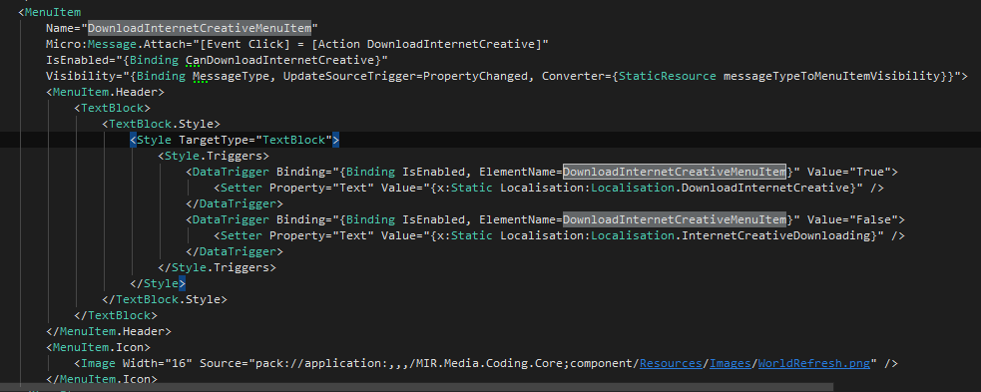

# Toto neni dataTrigger ale otoci to button podle property na kterou je bindovany Angle

**Zmenovadlo sipka**

public int Angle => ChangingViewModel.FilterViewModel.FiltersVisibility == Visibility.Visible ? 0 : 180;

<Button

x:Name="ArrowButton"

Command="{Binding FiltersVisibilityCommand}"

Style="{DynamicResource ButtonStyle1}" RenderTransformOrigin="0.5,0.5">

<Button.RenderTransform>

<TransformGroup>

<ScaleTransform/>

<SkewTransform/>

<RotateTransform Angle="{Binding Angle}"/>

<TranslateTransform/>

</TransformGroup>

</Button.RenderTransform>

**Notifikace je nutna. Tady se ale nedela v setteru, ale jinde :**

if (SelectedTabIndex == 0)

{

ChangingViewModel.FilterViewModel.FiltersVisibility = ChangingViewModel.FilterViewModel.FiltersVisibility == Visibility.Visible ? Visibility.Collapsed : Visibility.Visible;

NotifyOfPropertyChange(nameof(Angle));

}